Intergraph Impact Statement

History
Title: | Support customizable Plate knuckle rule
Author: | Yunfei Wang
Organization: | Intergraph
JTS Items: | DI 175936
Target Release | 2011
Created: | 01/11/2010
Last Modified: | 03/11/2010

Problem Description
2011 will implement support for plate system knuckles to be bent. This new functionality will also support a customizable rule that can be bulk-loaded to the catalog that will decide whether the knuckle should be split or bend and what the bend inner radius should be. If the code does not find a plate knuckle rule, the default value for the knuckle will be “split”

Impact

The delivered catalog will be delivered with a new Shipbuilding rule for defining the plate knuckle type.

Plate Knuckle Rule

IJPlateKnuckleRule interface
The plate knuckle rule is coded similarly to the profile rule except it implements the IJPlateKnuckleRule interface. This method defines one method:
ComputeKnuckleType(ByVal pPlate As Object, ByVal pPlateKnuckle As Object,
eManufacturingMethod As GSCADRefCurveOnSurface.enumKnuckleType)

ComputeKnuckleRadius(ByVal pPlate As Object, dInnerRadius As Double)

ComputeKnuckleType takes the plate and the knuckle as input and returns the knuckletype (“eKT_Bent” or “eKT_Split”)

ComputeKnuckleRadius takes the plate as input and returns the inner knuckle radius.

The inner knuckle is radius defined as the angle < 180 degrees at the knuckle. Example of potential knuckle radius is shown below:

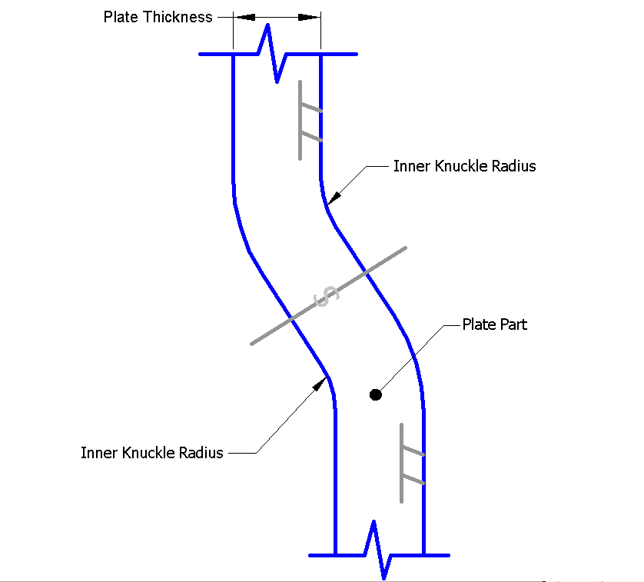

The outer radius is automatically calculated as the inner radius + plate thickness.

PlateKnuckleRule implementation

The dll for the plate knuckle rule should exist in the customer’s SharedContent/bin directory.

The rule is implemented using the following algorithm:

bCurveIsLinear = oPlateKnuckle.IsKnuckleCurveLinear

If bCurveIsLinear = True Then

m_eManufacturingMethod = eKT_Bent

Else

m_eManufacturingMethod = eKT_Split

End If

The plate knuckle supports a property that returns whether the knuckle curve is linear

If the knuckle is bent, the inner radius is computed using a range check based on the thickness of the plate.

For example:

dPlateThickness = oPlate.PlateThickness

dInnerRadius = 0.0

if (dPlateThickness < 0.01) then ‘ thickness < 10 mm

dInnerRadius = 0.05 “50 mm

else if (dPlateThickness < 0.02) then ‘ thickness < 20 mm

dInnerRadius = 0.1 “100 mm

else if (dPlateThickness < 0.03) then ‘ thickness < 30 mm

dInnerRadius = 0.15 “150 mm

else

dInnerRadius = 0.2 “200 mm

endif

End If

Catalog changes:

Two spreadsheets will be provided to load the new plate knuckle rule in the catalog. A_PlateKnuckleRuls.xls should be used for migrating databases from 2009.1 to 2011. This spreadsheet should be bulk-loaded in append mode. PlateKnuckleRule.xls is used for bulk-loading into new databases.

The plate knuckle rule is bulkloaded as an SRDRule and is located under the ShipBuilding Rules folder in the catalog. The application code expects to retrieve the rule using the rule number = 600.

Customer do not have to modify anything in the spreadsheet. The only changes that may need to be made are in the actual implementation of the rule. If the customers want to create their own rule with a different progID, the progID field in the xls will need to be changed (for both spreadsheets.
Definition | PartClassType | RuleClassType | RuleType | SingleRules
 | SRDRule | 600 | 603 | TRUE
!
Head | RuleName | ProgID | RuleListComponentId
Start
 | BendOrSplitPlateKnuckle | PlateKnuckleRule.BendOrSplitRule | 1
End

